Reading Sam.Gov Opportunity/Procurement type
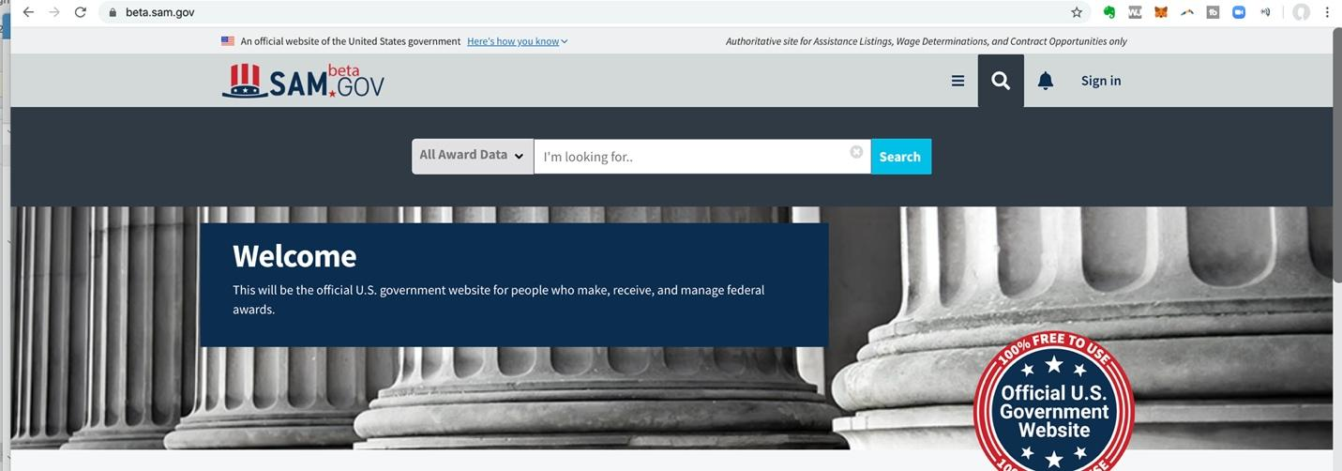

Good day all my future giants.
Tomorrow I will share my comments on how I utilize these tools to grow my federal business.

I found this to be helpful to me in making heads or tails from understanding what the mostly used solicitations mean...enjoy!
Award – Super easy to understand. This is the list you want your name on.
Combined Synopsis / Solicitation – This is a real, live, actual deal. Most opportunities classified this way are going to actually happen. All of these should include specifications for the product or service and a due date for the proposal. A “Combined” means the agency is expecting a proposal or quote from you.

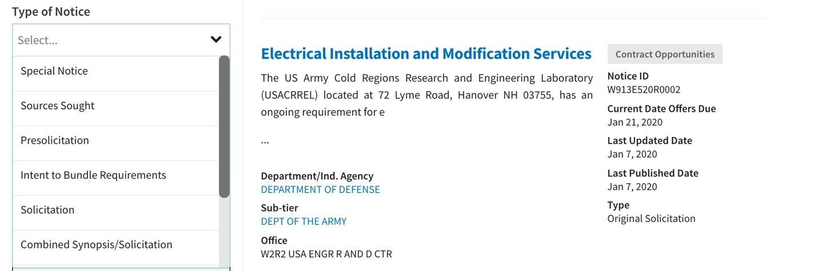

Sources Sought – A Sources Sought notification almost always means “Small Business Sources Sought.” The government is loosely required to “set-aside” a certain percentage of their procurements to small businesses. (This small business “requirement” has many, many exceptions, and there are many, many workarounds, but the general idea is sound.)

Sometimes the solicitation will specify explicitly that they are looking only for small businesses (or 8(a), HUBZone, …) to respond. (Even if it doesn’t say “only small businesses” it means only small businesses.) If a Sources Sought opportunity is in your wheelhouse then you’ll want to add it to your watchlist to manage. Sources Sought is your chance to “get in early.”
Pre-solicitation – Covers nearly everything else. In some cases, it’s really a “Special notice.” In others, it’s a Request for Information (RFI). Sometimes, the Pre-solicitation is, surprisingly, a pre-solicitation – meaning, the “real” solicitation isn’t released yet.
Special Notice – Could mean anything (unless you’re GSA). Often this is a way to post a “sole source” notification which means you aren’t getting the deal. [Learn how to get sole source contracts in the Govcon Giants course]

Other times it’s simply a notification of a follow on contract – again, you aren’t getting this one. In some cases (GSA in particular) it’s a Request for Quote or a notice that a RFQ is going to be issued. Still other times the description for the “Special Notice” will begin with the phrase “This is a combined synopsis/solicitation…” Really. (One of our favorites: F3PT710034AG01. The description reads: “this is a streamlined combined synopsis/solicitation…”)
Sale of Surplus Property – This is a new category that was not previously in the legacy system Fedbizopps. It looks like a new area where they are going to list or post properties available for sell. As of today's date I do not see any postings.

